Discovered in 1994, the Pentium FDIV bug is a hardware bug found on intel Pentium processors, which affected its ability to make correct floating-point divisions. The bug was, reportedly, an error in the form of missing entries in the lookup table used by the floating-point unit of the processor. Although byte magazine estimated that the processor would fail 1 out of 9 billion times calculating random divisions, in January 1995, Intel announced "a pre-tax charge of $475 million against earnings, ostensibly the total cost associated with replacement of the flawed processors." even though only a small fraction of users ended up replacing their Pentiums.

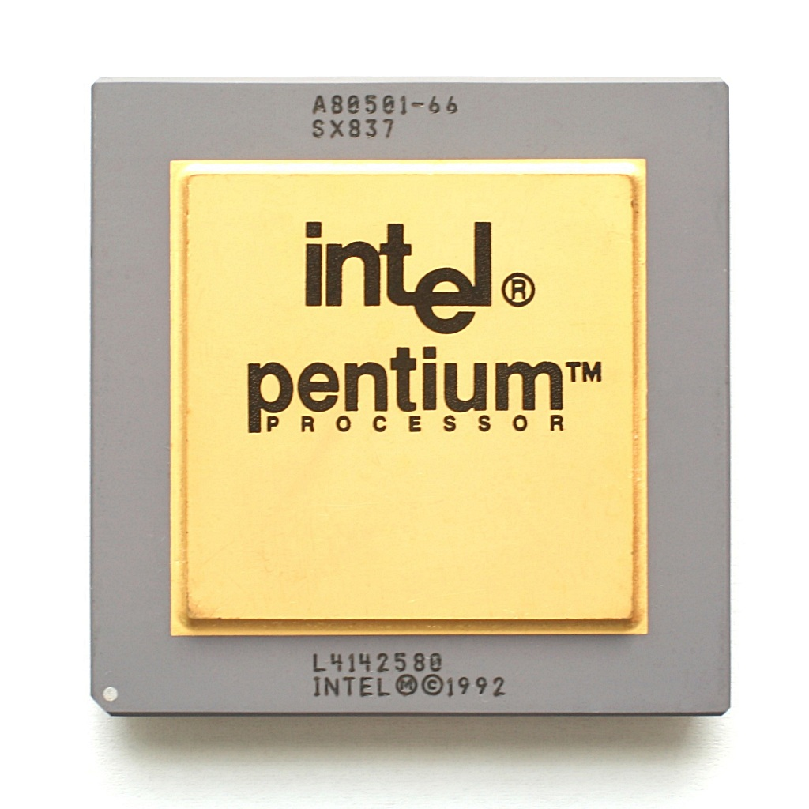The error can be checked by making the division $\frac{4,195,835}{3,145,727}$ on a program using native floating-point numbers. The correct answer would be 1.333820 but the bugged Pentiums would return 1.333739. The fact that Intel knew about this, 5 months prior to mathematician Thomas Nicely reporting it made the public criticize Intel for not taking action before. The bug was overall an expensive error and made the company lose trust from their customers.